**OLABISI ONABANJO UNIVERSITY**

College of Engineering & Environmental Studies

Faculty of Engineering

Ibogun Campus.

**MECHANICAL ENGINEERING DEPARTMENT**

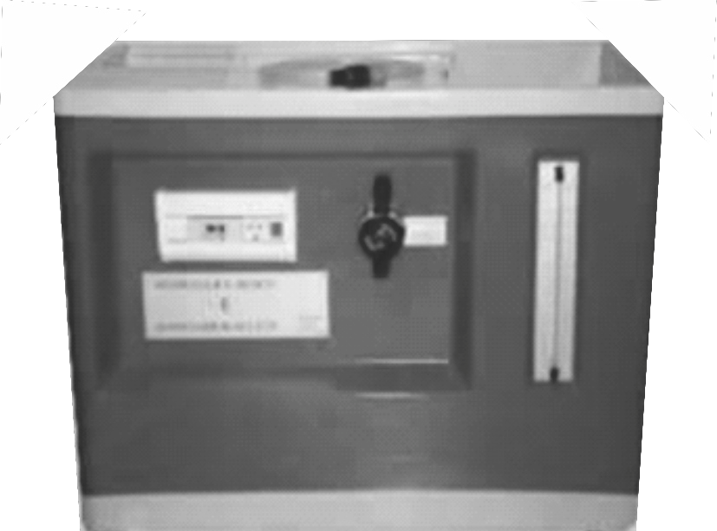

**FLUID MECHANICS**

**LABORATORY MANUAL**

**200 LEVEL**

**NAMES…………………………………………………………………………………........ MATRIC. NO. :……………………………… LEVEL: ……………………………….. DEPT.: ……………………………………….. GROUP NO: ………………………… COURSE:…………………………………….. CODE: ………………………………... DATE:………………… SESSION:………… SIGNATURE: ………………….........**

**INTRODUCTION**

**1. General**

The need for laboratory work in Mechanical Engineering is very important. Laboratory's course work enables students to do experiments on the fundamental laws and principles encountered in the theoretical work; to study and use a wide variety of measuring instruments and equipment, to learn and to handle them with skill and to appreciate their limitations.

**2. Conducting the Experiments**

The experiment should be planned in advance by consulting necessary reference books in order to understand the principles behind the experiment. Before starting the experiment, the following steps should be taken:- i. Produce the Sketch for the experiment, ii. Produce the working diagram of the experiment, iii. Write down, in the form of a table, all the measurements you propose to make, and the calculation or formula to be used to obtain the results.

**3. Records**

A faithful record of all observations taken should be made in the space provided in the tables contained in the laboratory manual and should be duly signed by the supervisor. To obtain accurate results, repeat the experiment using different methods where possible. The account of the experiment should be written in a practical notebook, which has graph paper on alternate pages. If the notebook is not ruled for graphical work, a sheet of graph paper can be interleaved when necessary between the double pages of the record. The report should be in a suitable format as follows:- i. Title, ii. Objectives, iii. Equipment/Apparatus/Materials,

iv. Theory/Diagram, v. Method/Procedures, vi. Measurements/Results, vii. Calculations viii. Graphs, ix. Results or Conclusion, x. References

**4. Attendance**

All students who registered for the laboratory courses must attend classes when required. There is a system of taking attendance register and this is considered when grading your laboratory work/report.

**5.0 Reference Tables**

**5.1 Multiple and Sub-multiples units and their abbreviations**

T = Tera = 1012, f = femto = 10-15

G = Giga = 109 , p = pico = 10-12

M = Mega = 106 , n = nano = 10-9

K = Kilo = 103 , u = Micro = 10-6

M = Milli = 10-3

1 MPa (MegaPascal) = 1 × 106 N/m2 = 1 N/mm2

1 GPa (GigaPascal) = 1 × 109 N/m2 = 1 kN/mm2

**5.2 Common Abbreviations**:

mA = milliAmeter, d = diameter, t = thickness, s = second, σ = stress, ε = strain

*l* = Original length of the body, Δ*l* = Change in length of the body, and

*E* = Young's modulus or modulus of elasticity*,* τ = Shear stress,

ϕ = Shear strain, *C* = Shear modulus (Modulus of rigidity).

**6. Graphs**

Whenever possible, the result of an experiment should be presented in graphical form. In plotting the results, the dependent variable should be plotted as ordinates on the y- axis, and the independent variable as abscissas on the x – axis. The scale used should a convenient one for arithmetical work, and should be sufficiently extensive for the graph to occupy a wide sweep of the space available. On the other hand, too large a scale will tend to accentuate the errors of observation and obscure the relationship between the two quantities.

**7.0 General Laboratory Safety**

Safety is one of the major elements of good laboratory management, but it is perhaps the most neglected. It should be understood that any use of electricity inherently involves some degree of safety hazard. Whilst every effort is made by responsible manufacturers to reduce the hazard, it is still rest with the users to play his part in ensuring his own safety.

The major-causes of laboratory accidents can be categorized into two:

Human cause which includes: i. Carelessness, ii. Ignorance, iii. Wrong attitudes, iv.Negligence.

**Contributory causes:**

I. Physical condition of students,

ii. Unsatisfactory or inappropriate equipment, iii. Diverted attention,

iv. Congested work stand, or inappropriate attire

**The best ways to achieve safety in the use of electrical equipment includes:**

i. Taking no chances, nor short cuts, in safety procedures.

**7.1 Safety**

This manual contains a number of guidelines which can help you perform your research works more safely and maintain better order and safety in our laboratories.

Each student is expected to read this manual thoroughly and act in agreement with the guidelines. This manual should also be kept available for future reference.

There are two golden rules in developing a safe and productive environment:

(1) Whenever you use a lab, it is your responsibility to see that unsafe conditions are corrected immediately; and (2) Always leave a laboratory in better condition than you found it.

If we all take this level of personal responsibility, our facilities can only improve.

We hope to periodically update and revise this manual to make it more useful and more effective. We hope keep you stay safe and productive.

Safety requires a careful and deliberate approach to each test before undertaking any experiment; the student must understand what to do and how to do it.

**7.2 Safety rules:**

The following important safety rules should be observed at all times:

i. Do not clown or gossip in the laboratories, ii. Do not sit on the work bench,

iii. Extraneous items should be removed from the table,

iv. Attention should be paid for clamping the job, tool, tool holders or supporting cutters.

v. Ask for instructions before the use of any item of test equipment for the first, time, even if you think you know how to use it. A little knowledge can be dangerous.

vi. Do not use any ring and wrist watch during practical periods. vii. Do not use any necklace or chain during practical periods. viii. Your hand nails must be dressed and properly maintained. ix. Avoid loose clothes in the laboratory and workshop.

x. Always wear safety goggle where necessary. xi. Do not eat nor drink during practical periods. xii. Ask when you do not know.

**MANDATORY PERSONAL PROTECTIVE WEARS FOR LABORATORY AND WORKSHOP**

i. White long sleeve laboratory coat for laboratory practical. ii. Blue long sleeve overall for workshop practical.

iii. Safety boot / hard sole leather shoe.

**FLUID MECHANICS**

**Table of contents**

Experiment 1 - Determination of flow measurement - 5

Experiment 2 -

Determination of volume and density of an object by the Archimedes' Principle

- 11

Experiment 3 -

Determination of fluid density by the principle of buoyancy - 18

Experiment 4 - Center of pressure apparatus - 26

Experiment 5 - Fluid Viscosity Measurement - 35

**EXPERIMENT 1**

**Title: Determination of Flow Measurement**

**Objectives**: (i) To measure the fluid flow (ii) To determine flow rate of the fluid

(iii) to determine the fluid density

**Equipment/Materials**: Volumetric bench, centrifugal pump, flexible hose, water, stop watch.

**Introduction**

The Hydraulic Bench provides the necessary facilities to support a comprehensive range of hydraulic models, each of which is designed to demonstrate a particular aspect of hydraulic theory.

The particular laws involved are mass, energy; momentum, conservation of energy and in each application, these laws may be simplified in an attempt to describe the fluid, quantity of the fluid and the fluid behaviour.

Fluid mechanics developed as an analytical discipline from the application of the classical laws of static,

dynamics and thermodynamics, in situations in which fluids can be treated as continuous media.

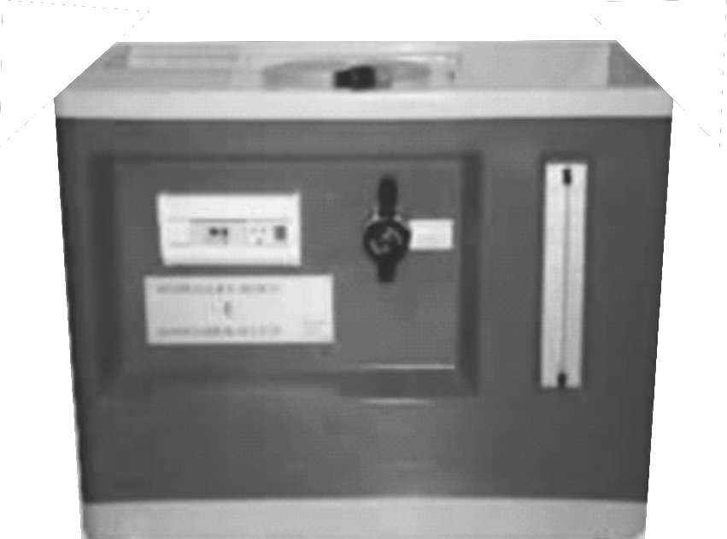

Figure 1.1: Volumetric Bench

A centrifugal pump draws water from sump tank and drives it through a vertical pipe. A control valve assembled in an external panel is used to regulate the flow in the pipe, which ends in a mouthpiece placed in the channel and has a quick connection connector. The male connector allows a quick substitution of the different accessories, which are supplied with a flexible tube ending in a female connector. Special purpose terminations may be connected to the pump supply by unscrewing the connector. No hand tools are required for any of these operations.

The moulded bench top incorporates an open channel, with side channels, to place the accessory on test. The channel incorporates a pair of wall slots and a weir, for use with accessory, in addition to the inlet connector.

A dump valve in the base of the volumetric tank is operated by a remote actuator.

Lifting the actuator, the dump valve opens allowing the inlet water to return to the sump for recycling. When lifted, a twist of 90º at the actuator will retain the dump valve in the open position.

An overflow made on a side of the volumetric tank, returns water to the sump in case an excessive height is reached. When working with an accessory, the water discharged is collected in a volumetric measuring tank. This tank is stepped to accommodate low or high flow rates and incorporates a stilling baffle, to reduce turbulence. At sight, a level tube, with a scale, is connected to the base of the volumetric tank and gives an instantaneous indication of water level.

A drain valve is incorporated in the wall of the sump to facilitate draining. A measuring cylinder is provided for the measurement of very small flow rates. The electrical supply to the motor-pump is made with an on-off switch placed on the bench. It also includes a **5A** fuse holder.

**Flow Measurements**

The bench top incorporates a volumetric measuring tank, which is stepped to accommodate for low or high flow rates. A stilling baffle is placed adjacent to the open channel, to reduce turbulence.A sight gauge consisting of a transparent tube and a scale, is connected to a connector in the base of the tank and gives an instantaneous indication of the water level. The scale is divided into two zones corresponding to the volume above and below the step in the tank. Finally, there is a remote hand-operating dump valve, in the base of the volumetric tank.

**Procedure**

1. Switch on the centrifugal pump.

2. Open the dump valve to empty the measuring tank.

3. When the measuring tank is empty, connect the pump and close the dump valve.

4. Write down the reading of the level tube (manometer)

5. Switch the chronometer (Stop watch) on and stop when you reach the required quantity.

6. Record your readings in tabular form,

Calculate the flow as it is illustrated in the following equation:





**Table 1.1: Table of values**

|  |  |  |  |  |  |  |
| --- | --- | --- | --- | --- | --- | --- |
| S/N | Final volume (L2) (Litres) | Initial volume (L1) (Litres) | Change in volume (∆L) (Litres) | Time taken(t) (sec) | Volumetric flow rate (Q) (Litres/sec.) | Mass flow rate (ṁ) (kg/sec) |
| 1 |  |  |  |  |  |  |
| 2 |  |  |  |  |  |  |
| 3 |  |  |  |  |  |  |
| 4 |  |  |  |  |  |  |
| 5 |  |  |  |  |  |  |
| 6 |  |  |  |  |  |  |
| 7 |  |  |  |  |  |  |

**Exercises**

a. Plot the graph of change in volume (∆V) against the time (sec).

b. Determine the slope of the graph in (a), what parameter does it reflect?

c. What is the equation of the line?

d. Estimate the average volumetric flow rate and mass flow rate. e. What is the importance of the flow rate in a fluid?

f. What are the possible precautions necessary to be observed?

***NOTE on flow measuring:***

***Warning: When finish the flow measures with the chronometer, the valve actuator must be pulled down to open the valve and empty the tank to avoid that the sump tank is empty and to prevent damaged of the centrifugal pump. When another time taking is going to be done, the actuator has to be pulled up to fill the volumetric tank and once finished the measurement, the actuator will be pulled down again.***

**PRACTICAL REPORT**

**Title: .........................................**

**Scale:**

x: ......................................

y: ......................................



**PRACTICAL REPORT**

**EXPERIMENT 2**

**TITLE**: **Determination of volume and density of an object by the Archimedes' Principle. INTRODUCTION**

Experimentally, when a body is partially or totally submerged in a fluid it appears that, the body weighs differently in the air than when it is out of the fluid. Similarly, when it is in the fluid it displaces an amount of the fluid equal to the volume of the body submerged. The basis of the principle of buoyancy was discovered by Archimedes principle.

**OBJECTIVES**

The objectives of the experiment are:

(i) to determine the volume of metal cube. (ii) to determine the density of metal cubes.

**APPARATUS/MATERIIALS:**

Metal cube, Vernier calliper, Micrometer screw gauge, Spring balance, thread.

**THEORY**

A body weighing in air experiences a reduction in weight W when completely immerse in a fluid. The volume of the body corresponds to the values of length and diameters of the solid body. The density of a substance is equal to the ratio of its mass to volume.

Hence, Density = mass/volume

Volume = mass/density

*Spring Balance*

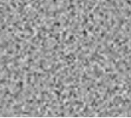

*Thread*

*Metal Cube*

Figure 2.1: Suspended solid body on spring

**PROCEDURE:**

a. Take the vernier calliper and measure the length of the metal cube given to you in range. b. Measure the diameter of the metal cube given to you in range and record you readings.

c. Suspend the metal cube by means of a thin thread from the spring balance and record its weight (W1) in air.

d. Repeat (i) for all the metal cube in range (10g, 20g, 30g, 40g, 50g, 60g, …..) and record their readings on the spring balance.

e. Record your readings in tabular form.

**EXERCISES:**

Values for metal cubes: Mass (kg) =

Length (m) = Diameter (m) =

Calculate the volume of the metal cube = Determine the density of the metal cube =

Table 2.1: Table of Results

|  |  |  |  |  |  |
| --- | --- | --- | --- | --- | --- |
| S/N | Mass | Length | Diameter | Volume | Density |
|  |  |  |  |  |  |
|  |  |  |  |  |  |
|  |  |  |  |  |  |
|  |  |  |  |  |  |
|  |  |  |  |  |  |
|  |  |  |  |  |  |
|  |  |  |  |  |  |
|  |  |  |  |  |  |

**RESULTS AND CALCULATIONS**

1. Plot a graph of *Mass M* against *Volume V* for each of the metal cubes provided.

2. Determine the slope of each of these graph, hence deduce the values of their various densities.

3. Compare the calculated volume with experimental volume from your graph.

4. Compare the calculated density with experimental density from your graph.

5. Explain the Principles of buoyancy.

**PRACTICAL REPORT**

**PRACTICAL REPORT**

**Title: .........................................**

**Scale:**

x: ......................................

y: ......................................



**PRACTICAL REPORT**

**PRACTICAL REPORT**

**EXPERIMENT 3**

**TITLE: Determination of fluid density by the principle of buoyancy**

**INTRODUCTION**

When a body is partially or totally submerged in a fluid, it displaces an amount of the fluid equal to the volume of the body submerged. Similarly, the body appears to the weight differently when out of the fluid and when in the fluid. The basis of the principle of buoyancy was discovered by Archimedes principle.

**OBJECTIVES:**

(a) To determine the relation between the change in weight (Mass) of the submerged body and the volume of fluid displaced. (b) To determine the density of various fluids by the relation of their up thrust and volume of fluid displaced.

**APPARATUS/MATERIIALS**: Spring balance, Metal cube, String (rope), fluids

**THEORY:** A body weighing in air experiences a reduction if weight W when completely immerse in a fluid. The volume of the body (totally submerged) corresponds to the volume of fluid displaced while the apparent weight loss W describes the up thrust force acting in the body. Fig. 3.1 illustrates the above mentioned.

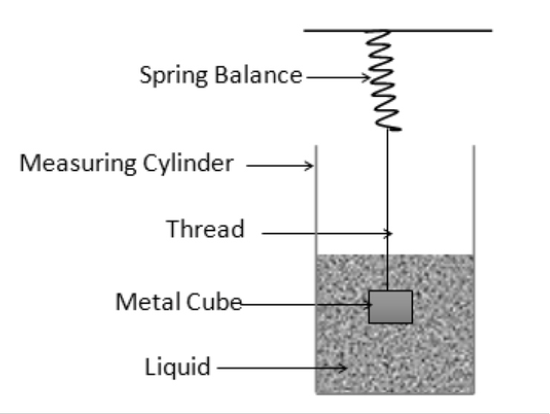

Figure 3.1: Buoyancy Experimental set up

**PROCEDURE:**

(i) Suspend the metal cube by means of a thin thread from the spring balance and record its weight W1 in air. (ii) Next, note the reading of the Liquid Level L1 in the measuring cylinder A1. Note that the new reading of

the Liquid Level and hence the change in volume.

(iii) Also, take the new reading of the spring balance W2.

(iv) Record your result weight in air, weight in Liquid, Mass in air, Mass in Liquid, Loss in Mass, initial and final liquid level and the change in Liquid in tabular form.

(iv) Repeat the procedure for Liquid L2, L3, and L4, using each time metal cubes of mass 20, 30, 40, 50, 60,

70, 80g, and 50g, 100g, 150g, 200g & 250g.

**RESULTS AND CALCULATIONS EXERCISES:**

1. Plot a graph of = M1-M2 against  = V2-V1 for water, Kerosene and Diesel liquids provided.

2. Determine the slope of each of these graph, hence deduce the values of their various densities.

3. Suppose you have plotted a graph of the change in weight W against V What parameter would the slope of the graph reflect?

4. Explain the significance of buoyancy in the parachute and the hot air balloon.

5. Describe briefly how the hydrometer measures the relative density of a liquid.

6. A cube made of Oak and of side 15cm floats in water with 10.5cm of its depth below the surface and its side vertical. What is the density of the Oak?

7. A body of density 9.0g/cm3 appears to have a mass of 27.0g in a liquid of density 1.2g/cm3.

What is the volume of the solid?

8. State Archimedes' Principles.

**PRACTICAL REPORT**

**Title: .........................................**

**Scale:**

x: ......................................

y: ......................................



**Title: .........................................**

**Scale:**

x: ......................................

y: ......................................



**Title: .........................................**

**Scale:**

x: ......................................

y: ......................................



**PRACTICAL REPORT**

**PRACTICAL REPORT**

**EXPERIMENT 4**

**TITLE: Centre of Pressure Apparatus**

**Aim/Objective**: To determine the moment of the fluid pressure acting on the plane surface.

**Equipment/ Apparatus**: Perspex tank, fluid (water), weight (mass), weight hanger, spirit level, coloured ink,

**Introduction**

Definition of Centre of Pressure: Centre of pressure may be defined as the point in a plane at which the total fluid thrust can be said to be acting normal to that plane.

The Centre of Pressure Apparatus permits the moment due to the fluid thrust on a wholly or partially submerged plane surface to be measured directly and compared with theoretical analysis. Provision is made for varying the inclination of the plane surface subjected to the fluid pressure so that the general case may be studied.

**Description of Apparatus**

Water is contained in a quadrant of a semi-circular Perspex tank assembly which is allowed to swing on a smooth bar. The cylindrical sides of the quadrant have their axes coincident with the centre of rotation of the tank assembly, and therefore the total fluid pressure acting on these surfaces exerts no moment about that centre. The only moment present is that due to the fluid pressure acting on the plane surface. This moment is measured experimentally by applying weights to a weight hanger mounted on the opposite side to the quadrant tank.

A second tank, situated on the same side of the assembly as the weight hanger, provides a trimming facility and enables different angles of balance to be achieved.

The angular position of the plane and height of water above it are measured on an angular scale engraved on the tank and linear scale panel.

Included with the apparatus are base levelling feet and a spirit level.

With the quadrant tank of the hopper fabrication held to the right-hand side, fit the hopper fabrication onto the centre support of the main frame assembly.

Level the base plate by screwing the adjustable feet and observing the spirit level. A coloured dye is supplied with the apparatus, which can be added to the water to help observation during experimentation. It should only be necessary to add small amount of dye (one or two cupful) to produce suitable colouring.

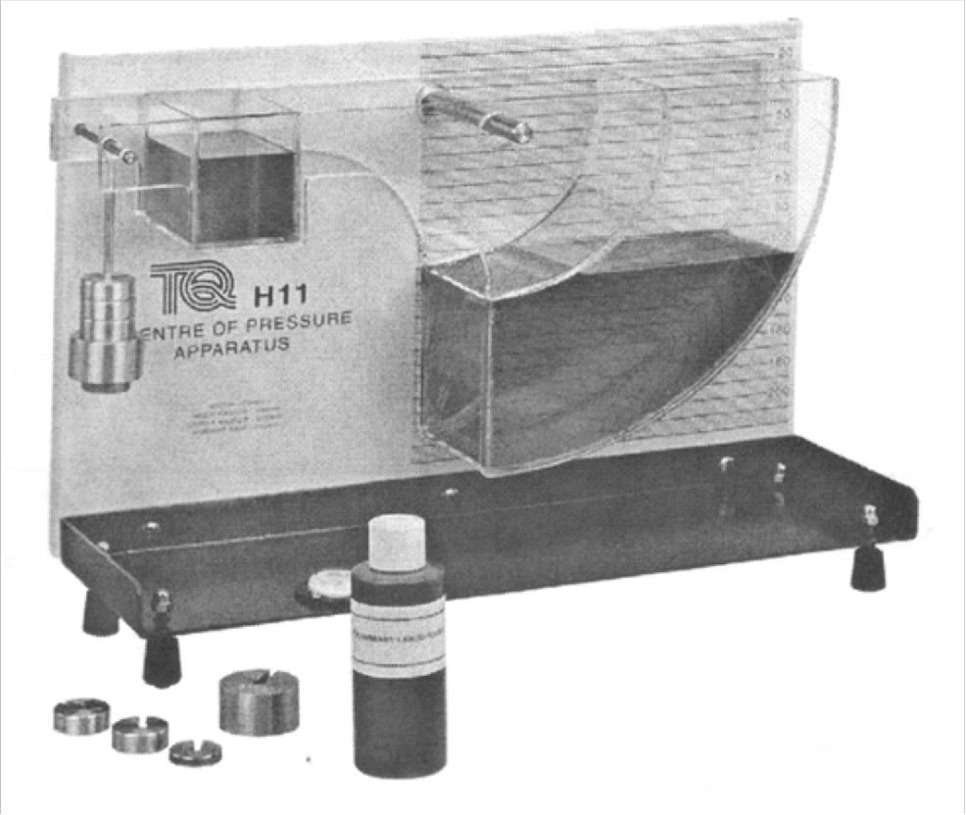

Figure 4.1: Centre of Pressure Apparatus

**Theory:**

Centre of pressure may be defined as the point in a plane at which the total fluid thrust can be said to be acting normal to that plane.

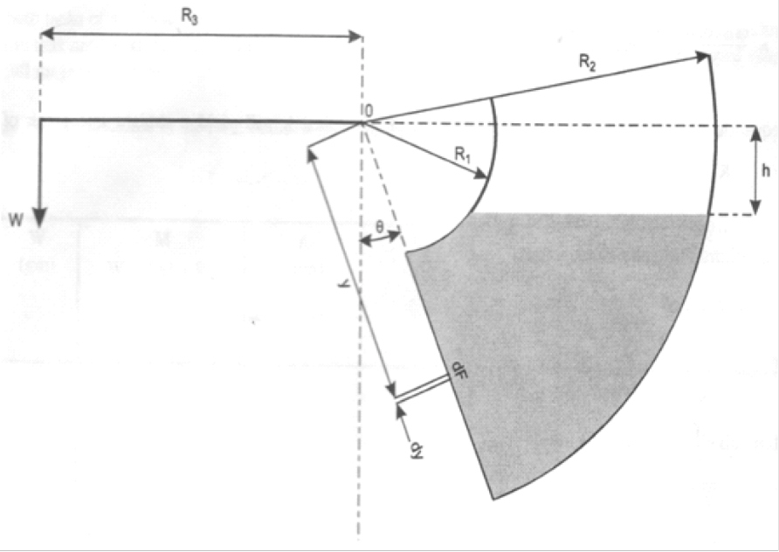Figure 4.2: Schematic of Centre of Pressure Apparatus

Analysis:

The following analysis applies to the condition of a plane surface at various angles when it is wholly or partially submerged in a fluid.

Let breadth of quadrant = B

And weight per unit volume = w

Referring to Figure 4.2 consider an element at start depth y, width y



Force on element f = w(y cos θ – h) B y

And the moment of force on element about 0 = w B(y cos θ – h) y y

Therefore, total moment about 0 = M= wB (cosθy2 – hy) y

**Experimental Procedure:**

(i) Set up the equipment as previously described above, and affix the weight hanger to the hanger support located on top of the hopper.

(ii) The apparatus will now require trimming in order to bring the submerged plane to the vertical (i.e 0o position).

This is achieved by gently pouring water into the trim tank until the desired position is achieved. The horizontal line on the tank assembly should be read against the zero line on the back scale.

(iii) Add a 20g weight (w) to the weight hanger. Pour water, with dye added if necessary, into the quadrant tank until a 0o balance is restored.

(iv) Note the weight and the height reading of the water (h).

(v) Repeat the procedure for the full range of weights.

Readings should be tabulated in the table below and the results calculated in line with the theory given above.

Table 4.1: Table of results

|  |  |  |  |  |  |  |
| --- | --- | --- | --- | --- | --- | --- |
| W (gm) | M = (W × 9.81 × R3/10^3) (Nm) | h (mm) | h (m) | h3 (m3) | M+(ωBR 2h/2)(Nm)  2 | θ0 |
|  |  |  |  |  |  |  |
|  |  |  |  |  |  |  |
|  |  |  |  |  |  |  |
|  |  |  |  |  |  |  |
|  |  |  |  |  |  |  |
|  |  |  |  |  |  |  |

Figures 4.3 and 4.4 show the general form of the graphs expected from this experiment.

M

h

Figure 4.3: Graph shown plane fully submerged

M+(ωBR 2/2)

2

h3 (m3)

Figure 4.4: Graph shown plane partially submerged

The results obtained from this experiment tend to agree very well with results calculated from hydrostatic theory. Disagreement between observation and theory is likely to be due to error in measurement or the construction tolerances of the apparatus rather than to any imprecision of the theory.

The apparatus should be cleaned regularly using soap water. When cleaning, care should be taken to ensure that no traces of grit or any hard abrasive materials are present on used cloth used. Do not use any materials containing man-made fibres as these will scratch the Perspex.

EXERCISES:

(a) Plot the graph of M against h.

(b) Determine the slope of the graph in (a).

(c) Plot the graph of M+(ωBR 2h/2) (Nm) against h3 (m3). (d) Determine the slope of the graph in (b).

2

(e) What is the moment of the fluid pressure?

(f) What are the precautions to be observed in the experiment?

**PRACTICAL REPORT**

**PRACTICAL REPORT**

**Title: .........................................**

**Scale:**

x: ......................................

y: ......................................



**Title: .........................................**

**Scale:**

x: ......................................

y: ......................................



**PRACTICAL REPORT**

**EXPERIMENT 5**

**Title: Fluid Viscosity Measurement**

**Objective(s):** The objective is to determine the viscosity (kinematic and dynamic) of various fluids.

**Apparatus/Materials:** Cannon-Fenske Viscometer(s), fluids (water, paraffin/kerosene, diesel, petrol, engine oil, P.K.O. oil), temperature bath, Holder/retort stand, stopwatch.

**Theory:** Viscometry is the method of measuring the viscosity of a fluid. Cannon-Fenske viscometer is an instrument used to measure kinematic viscosity of a fluid, it can be used to calculate absolute (dynamic) viscosity. Each Cannon-Fenske tube has its own calibrated constant, which is multiplied by the recorded time in second to obtain kinematic viscosity in cSt, that is: n = k * t,

where k is the viscometer constant in cSt/seconds and t is time in seconds.

The kinematic viscosity (centistrokes) is the efflux time multiplying by the viscometer constant. Absolute (dynamic) viscosity (Ns/m2) = kinematic viscosity (cSt) * density (g/cm3)

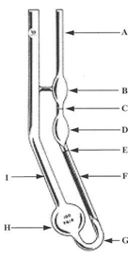Diagram:

Table 5.1: Recommended Viscosity Constant value for Cannon-Fenske Viscometers

Figure 5.1: Cannon-Fenske Viscometer

|  |  |
| --- | --- |
| **Size** | **Approx. Constant value (cSt)** |
| 25 | 0.002 |
| 50 | 0.004 |
| 75 | 0.008 |
| 100 | 0.015 |
| 150 | 0.035 |
| 200 | 0.100 |
| 300 | 0.250 |
| 350 | 0.500 |
| 400 | 1.200 |
| 450 | 2.500 |
| 500 | 8.000 |
| 600 | 20.000 |
| 650 | 45.000 |

**Procedures**:

1. Cleaned viscometer with a suitable solvent and dried in a stream of clean, filtered N2.

2. The instrument should be periodically cleaned with chromic acid to remove any possible traces of organic deposits.

3. Remove lint/hair, dust/dirt or other solid material that may be present in the liquid sample by filtering through sintered glass filter/fine mesh screen/sieve cloth to avoid any chances of particle contamination

4. Put the liquid into the measuring cylinder/container, invert viscometer to charge with the test sample, submerge/dip tube [A] into liquid and apply suction tube to [I], to introduce sample into the viscometer, which causes the sample to rise to etched line [E]. Then turn the viscometer to normal position and wipe clean tube [A] carefully.

5. Place the viscometer into a holder and put in constant temperature bath. Allow some minutes for viscometer to reach equilibrium at desired temperature (10 min or more depend on the temperature; the higher the temperature the longer the waiting time).

6. Vertical alignment may be accomplished in bath by suspending a plumb bob in tube [I].

7. Apply suction to tube [A] and bring sample into bulb [B] a short distance above mark [C]

8. Use the stopwatch to determine the efflux time by allowing the sample to flow freely through mark [C], measuring the time for the meniscus to pass from [C] to [E].

9. Repeat steps 7 and 8 to repeat efflux time measurement.

**Note and record: Viscometer size: ……………, Viscometer constant value:………………. Exercises:**

1. Determine the efflux time of the fluid.

2. Calculate the kinematic viscosity of the fluid.

3. Estimate the dynamic viscosity of the fluid.

4. Compare your results with the fluid viscosity standard.

5. State the precaution(s) you observed during the experiment.

**References**

1. Kreith F.; Berger S. A, et al. (1999): “Fluid Mechanics” Engineering Handbook Ed. Frank Kreith, Boca

Raton: CRC Press LLC, 1999, pp. 3-194.

2. Cannon-Fenske Viscometer Instrument Manual.

3. Bear Jacob, Dynamics of Fluids in Porous Media, Dover Publications, INC. New York 1972.

**PRACTICAL REPORT**

**PRACTICAL REPORT**